For Table 1

INSERT INTO classroom VALUES ('Science Hall', '101', 50);

INSERT INTO classroom VALUES ('Science Hall', '102', 45);

INSERT INTO classroom VALUES ('Engineering Bldg', '201', 60);

INSERT INTO classroom VALUES ('Engineering Bldg', '202', 55);

INSERT INTO classroom VALUES ('Arts Center', 'A01', 40);

INSERT INTO classroom VALUES ('Arts Center', 'A02', 35);

INSERT INTO classroom VALUES ('Library', 'L1', 20);

INSERT INTO classroom VALUES ('Library', 'L2', 25);

INSERT INTO classroom VALUES ('Business Wing', 'B101', 30);

INSERT INTO classroom VALUES ('Business Wing', 'B102', 50);

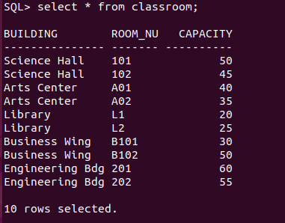

For Table 2

INSERT INTO department VALUES ('Computer Science', 'Science Hall', 120000.00);

INSERT INTO department VALUES ('Mathematics', 'Engineering Bdg', 80000.50);

INSERT INTO department VALUES ('Physics', 'Science Hall', 100000.75);

INSERT INTO department VALUES ('Chemistry', 'Research Center', 95000.00);

INSERT INTO department VALUES ('Biology', 'Life Sciences', 87000.00);

INSERT INTO department VALUES ('English', 'Arts Center', 60000.00);

INSERT INTO department VALUES ('History', 'Humanities Wing', 55000.00);

INSERT INTO department VALUES ('Business', 'Business Wing', 150000.00);

INSERT INTO department VALUES ('Economics', 'Business Wing', 92000.00);

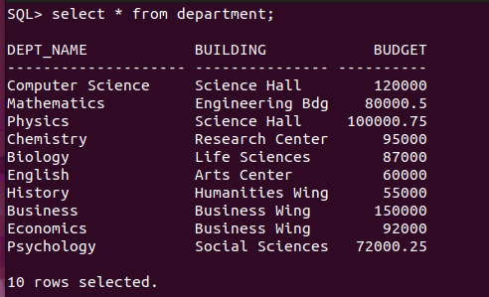INSERT INTO department VALUES ('Psychology', 'Social Sciences', 72000.25);

For Table 3

INSERT INTO course VALUES ('CS101', 'Introduction to Computer Science', 'Computer Science', 3);

INSERT INTO course VALUES ('CS102', 'Data Structures', 'Computer Science', 4);

INSERT INTO course VALUES ('MATH201', 'Calculus I', 'Mathematics', 3);

INSERT INTO course VALUES ('MATH202', 'Linear Algebra', 'Mathematics', 3);

INSERT INTO course VALUES ('PHYS301', 'Classical Mechanics', 'Physics', 4);

INSERT INTO course VALUES ('CHEM101', 'Organic Chemistry', 'Chemistry', 4);

INSERT INTO course VALUES ('BIO101', 'General Biology', 'Biology', 3);

INSERT INTO course VALUES ('ENG101', 'English Literature', 'English', 3);

INSERT INTO course VALUES ('HIST201', 'World History', 'History', 3);

INSERT INTO course VALUES ('BUS101', 'Principles of Management', 'Business', 3);

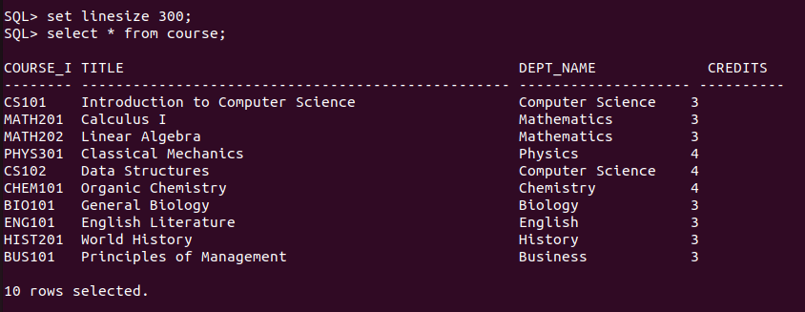

For Table 4

INSERT INTO instructor VALUES ('I001', 'John Doe', 'Computer Science', 50000.00);

INSERT INTO instructor VALUES ('I002', 'Jane Smith', 'Mathematics', 60000.00);

INSERT INTO instructor VALUES ('I003', 'David Lee', 'Physics', 55000.00);

INSERT INTO instructor VALUES ('I004', 'Sarah Jones', 'English', 45000.00);

INSERT INTO instructor VALUES ('I005', 'Michael Brown', 'Business', 70000.00);

INSERT INTO instructor VALUES ('I006', 'Emily Davis', 'History', 48000.00);

INSERT INTO instructor VALUES ('I007', 'Daniel Wilson', 'Psychology', 52000.00);

INSERT INTO instructor VALUES ('I008', 'Olivia Taylor', 'Computer Science', 65000.00);

INSERT INTO instructor VALUES ('I009', 'James Anderson', 'Mathematics', 58000.00);

INSERT INTO instructor VALUES ('I010', 'Sophia Clark', 'Physics', 49000.00);

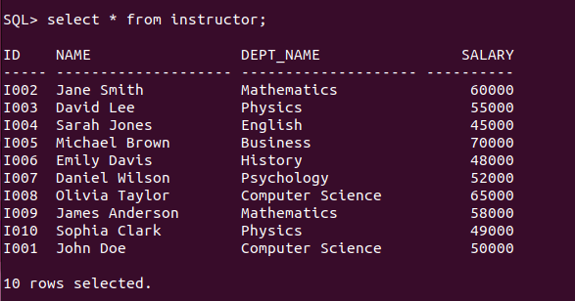

For Table 5

INSERT INTO section VALUES ('CS101', 'A1', 'Fall', 2023, 'Science Hall', '101', 'T1');

INSERT INTO section VALUES ('MATH201', 'B1', 'Spring', 2024, 'Science Hall', '102', 'T2');

INSERT INTO section VALUES ('MATH202', 'C1', 'Fall', 2023, 'Engineering Bdg', '201', 'T3');

INSERT INTO section VALUES ('PHYS301', 'D1', 'Spring', 2024, 'Engineering Bdg', '202', 'T4');

INSERT INTO section VALUES ('ENG101', 'E1', 'Fall', 2023, 'Arts Center', 'A01', 'T5');

INSERT INTO section VALUES ('HIST201', 'F1', 'Spring', 2024, 'Arts Center', 'A02', 'T6');

INSERT INTO section VALUES ('BIO101', 'G1', 'Fall', 2023, 'Library', 'L1', 'T7');

INSERT INTO section VALUES ('CS102', 'H1', 'Spring', 2024, 'Library', 'L2', 'T8');

INSERT INTO section VALUES ('CHEM101', 'I1', 'Fall', 2023, 'Business Wing', 'B101', 'T9');

INSERT INTO section VALUES ('BUS101', 'J1', 'Spring', 2024, 'Business Wing', 'B102', 'T10');

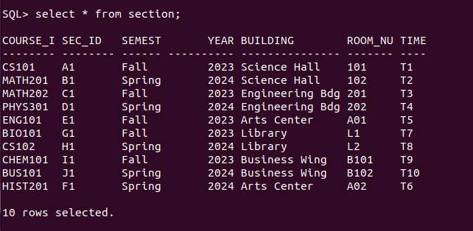

For Table 6

INSERT INTO teaches VALUES ('I001', 'CS101', 'A1', 'Fall', 2023);

INSERT INTO teaches VALUES ('I002', 'MATH201', 'B1', 'Spring', 2024);

INSERT INTO teaches VALUES ('I003', 'MATH202', 'C1', 'Fall', 2023);

INSERT INTO teaches VALUES ('I004', 'PHYS301', 'D1', 'Spring', 2024);

INSERT INTO teaches VALUES ('I005', 'ENG101', 'E1', 'Fall', 2023);

INSERT INTO teaches VALUES ('I006', 'HIST201', 'F1', 'Spring', 2024);

INSERT INTO teaches VALUES ('I007', 'BIO101', 'G1', 'Fall', 2023);

INSERT INTO teaches VALUES ('I008', 'CS102', 'H1', 'Spring', 2024);

INSERT INTO teaches VALUES ('I009', 'CHEM101', 'I1', 'Fall', 2023);

INSERT INTO teaches VALUES ('I010', 'BUS101', 'J1', 'Spring', 2024);

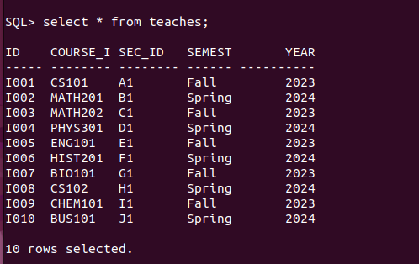

For Table 7

INSERT INTO student VALUES ('S1001', 'Alice', 'Computer Science', 30);

INSERT INTO student VALUES ('S1002', 'Bob', 'Mathematics', 45);

INSERT INTO student VALUES ('S1003', 'Charlie', 'Physics', 20);

INSERT INTO student VALUES ('S1004', 'David', 'English', 60);

INSERT INTO student VALUES ('S1005', 'Eve', 'Business', 15);

INSERT INTO student VALUES ('S1006', 'Frank', 'History', 35);

INSERT INTO student VALUES ('S1007', 'Grace', 'Psychology', 25);

INSERT INTO student VALUES ('S1008', 'Henry', 'Computer Science', 50);

INSERT INTO student VALUES ('S1009', 'Ivy', 'Mathematics', 40);

INSERT INTO student VALUES ('S1010', 'Jack', 'Physics', 10);

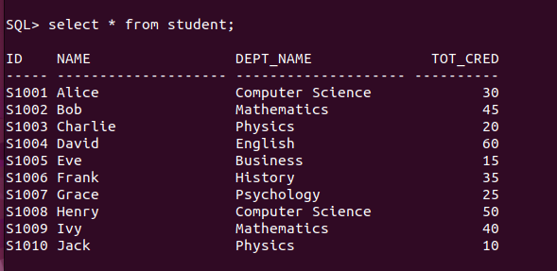

For Table 8

INSERT INTO takes VALUES ('S1001', 'CS101', 'A1', 'Fall', 2023, 'A');

INSERT INTO takes VALUES ('S1002', 'MATH201', 'B1', 'Spring', 2024, 'B');

INSERT INTO takes VALUES ('S1003', 'MATH202', 'C1', 'Fall', 2023, 'C');

INSERT INTO takes VALUES ('S1004', 'PHYS301', 'D1', 'Spring', 2024, 'A');

INSERT INTO takes VALUES ('S1005', 'ENG101', 'E1', 'Fall', 2023, 'B');

INSERT INTO takes VALUES ('S1006', 'HIST201', 'F1', 'Spring', 2024, 'C');

INSERT INTO takes VALUES ('S1007', 'BIO101', 'G1', 'Fall', 2023, 'A');

INSERT INTO takes VALUES ('S1008', 'CS102', 'H1', 'Spring', 2024, 'B');

INSERT INTO takes VALUES ('S1009', ‘CHEM101’, 'I1', 'Fall', 2023, 'A');

INSERT INTO takes VALUES ('S1010', 'BUS101', 'J1', 'Spring', 2024, 'C');

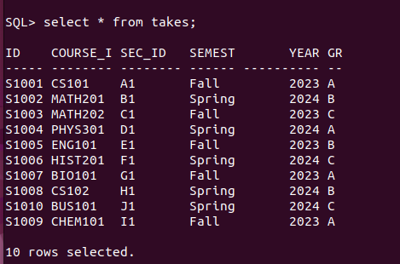

For Table 9

INSERT INTO advisor VALUES ('S1001', 'I001');

INSERT INTO advisor VALUES ('S1002', 'I002');

INSERT INTO advisor VALUES ('S1003', 'I003');

INSERT INTO advisor VALUES ('S1004', 'I004');

INSERT INTO advisor VALUES ('S1005', 'I005');

INSERT INTO advisor VALUES ('S1006', 'I006');

INSERT INTO advisor VALUES ('S1007', 'I007');

INSERT INTO advisor VALUES ('S1008', 'I008');

INSERT INTO advisor VALUES ('S1009', 'I009');

INSERT INTO advisor VALUES ('S1010', 'I010');

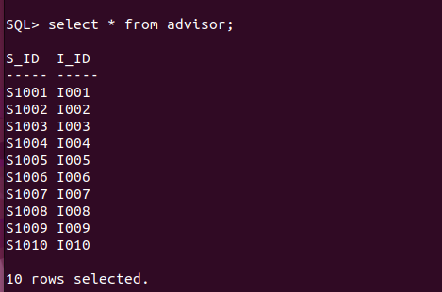

For Table 10

INSERT INTO time_slot VALUES ('T1', 'M', 9, 0, 9, 50);

INSERT INTO time_slot VALUES ('T2', 'W', 10, 0, 10, 50);

INSERT INTO time_slot VALUES ('T3', 'F', 11, 0, 11, 50);

INSERT INTO time_slot VALUES ('T4', 'M', 13, 0, 13, 50);

INSERT INTO time_slot VALUES ('T5', 'W', 14, 0, 14, 50);

INSERT INTO time_slot VALUES ('T6', 'F', 15, 0, 15, 50);

INSERT INTO time_slot VALUES ('T7', 'M', 16, 0, 16, 50);

INSERT INTO time_slot VALUES ('T8', 'W', 17, 0, 17, 50);

INSERT INTO time_slot VALUES ('T9', 'F', 18, 0, 18, 50);

INSERT INTO time_slot VALUES ('T10', 'M', 19, 0, 19, 50);

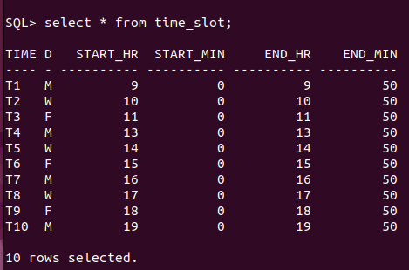

INSERT INTO prereq VALUES ('EE202', 'EE101');

INSERT INTO prereq VALUES ('MA202', 'MA101');

INSERT INTO prereq VALUES ('PH201', 'PH101');

INSERT INTO prereq VALUES ('CS401', 'CS301');

INSERT INTO prereq VALUES ('EE301', 'EE202');

INSERT INTO prereq VALUES ('MA301', 'MA202');

INSERT INTO prereq VALUES ('PH301', 'PH201');

INSERT INTO prereq VALUES ('CS501', 'CS401');

